Terraform -02
1.Watch the Terraform-02 video.
Topics in Video 02
Mutable vs Immutable Infrastructure:
- Mutable Infrastructure
- Definition: Existing infrastructure is updated/modified to reach the desired state.
- Example: You update a running EC2 instance to install a new version of software.

- Immutable Infrastructure
- Definition: Instead of modifying existing infrastructure,Terraform destroys the old resource and creates a fresh one with the new configuration.
- Example: Replace an EC2 instance with a new one that has the updated software
- Advantages: Ensure consistency

Terraform Lifecycle Rules:
Terraform allows you to control how resources are Created, Destroyed< or Moddified with the lifecycle block.
Variables in Terraform
Variables make Terraform configurations Dynamic and reusable.
Basic Structure:
variable “filename” {
default = “/root/pets.txt”
type = string
description = “Path to the pets file”
}

- Default: Optional default value.
- Type: Ensures variable type safety.
- Description: Documentation for humans.
Variable Types
string
- Example: "I love pets"
- Use case: Stores text values
number
- Example: 1, 8080
- Use case: Stores numeric values (CPU count, port numbers)
bool
- Example: true, false
- Use case: Used for flags or toggles
any
- Example: Can be string, number, list, etc.
- Use case: Accepts any data type (flexible use)
list
- Example: ["cat", "dog"]
- Use case: Ordered collection of items
map
- Example: { pet1 = "cat", pet2 = "dog" }
- Use case: Stores key–value pairs
object
- Example: { name = "dog", age = 5 }
- Use case: Complex structured data with named attributes
tuple
- Example: ["dog", 5, true]
- Use case: Mixed data types in a fixed order

2.Execute all the templates shown in the video.
Main.tf main configuration file containing resource definition
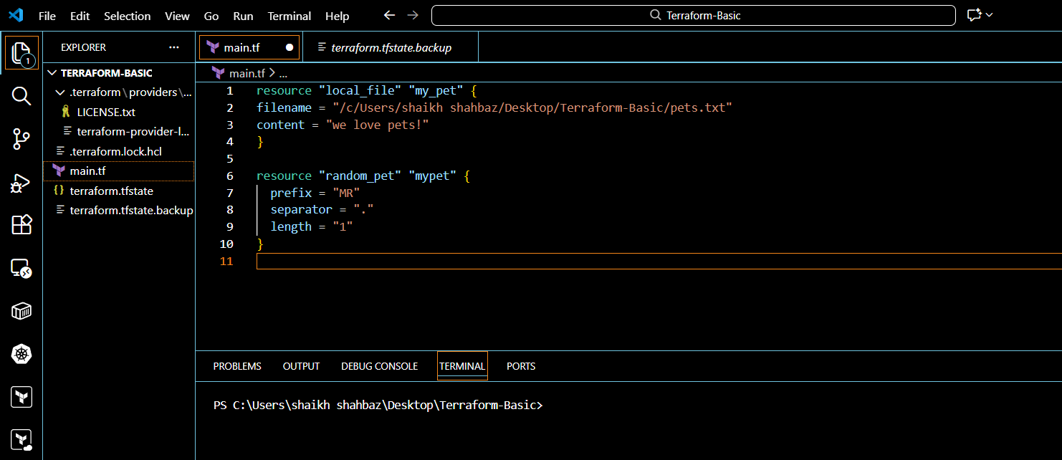

Terraform mutable vs immutable infrastructure:
Terraform as a IAC tool uses immutable infrastructure stratgey.
Immutable means deleting the older infra and creating a newer one with new update.
Mutable means using the existing infra and updating the system with newer version.
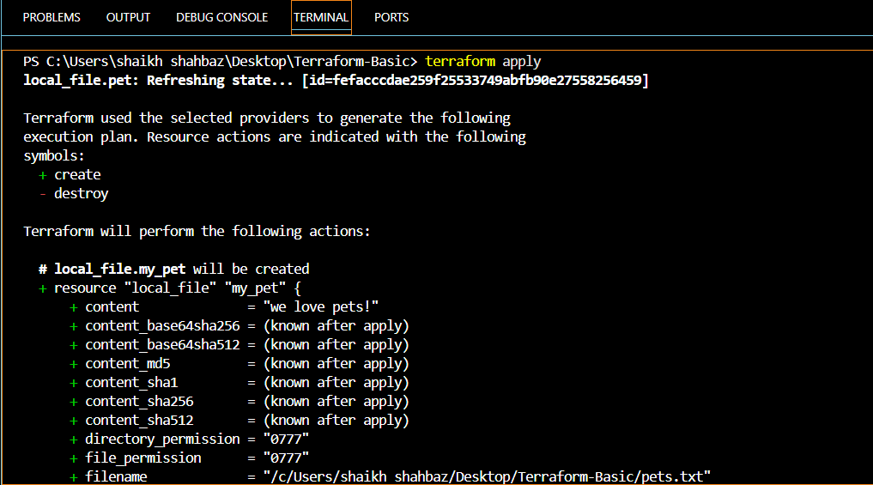
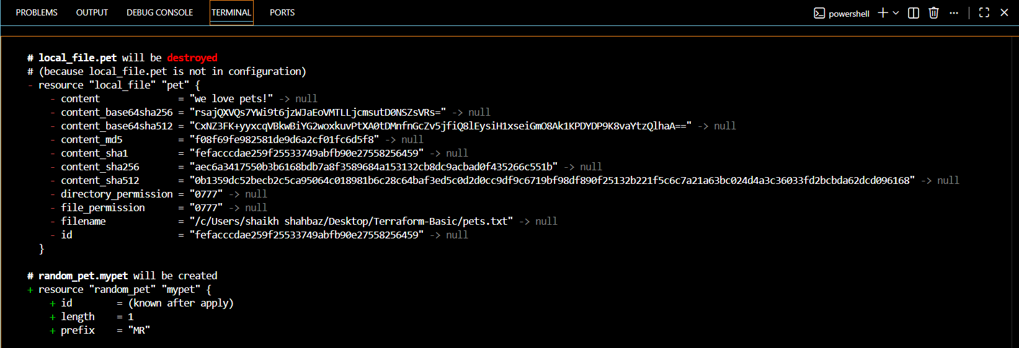
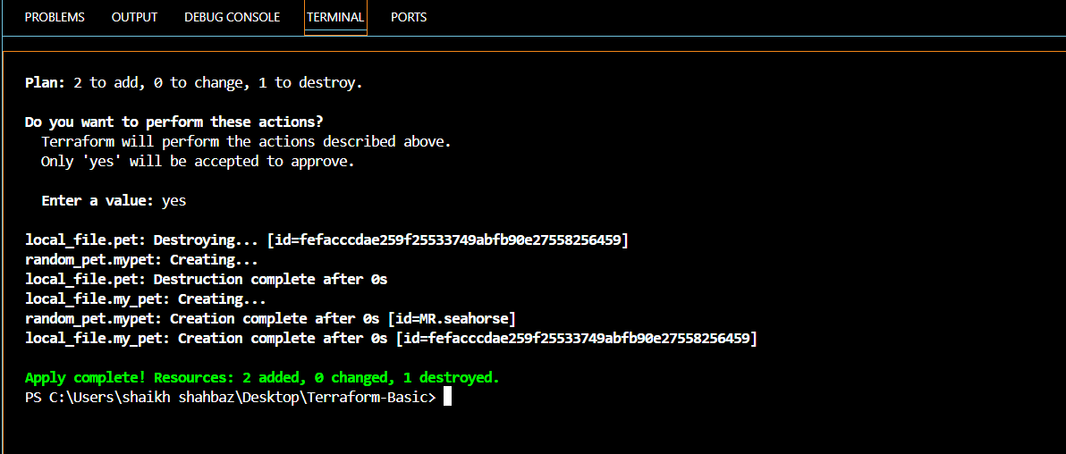

Lifecycle:
Lifecycle is a special block inside a resource that tells Terraform how to behave when a resource is created, updated, or deleted.
In simple words:
Lifecycle controls what Terraform should do and what it should Not do with a resource.

1.Create_before_destroy:
Terraform creates a new resource first, then deletes the old one.
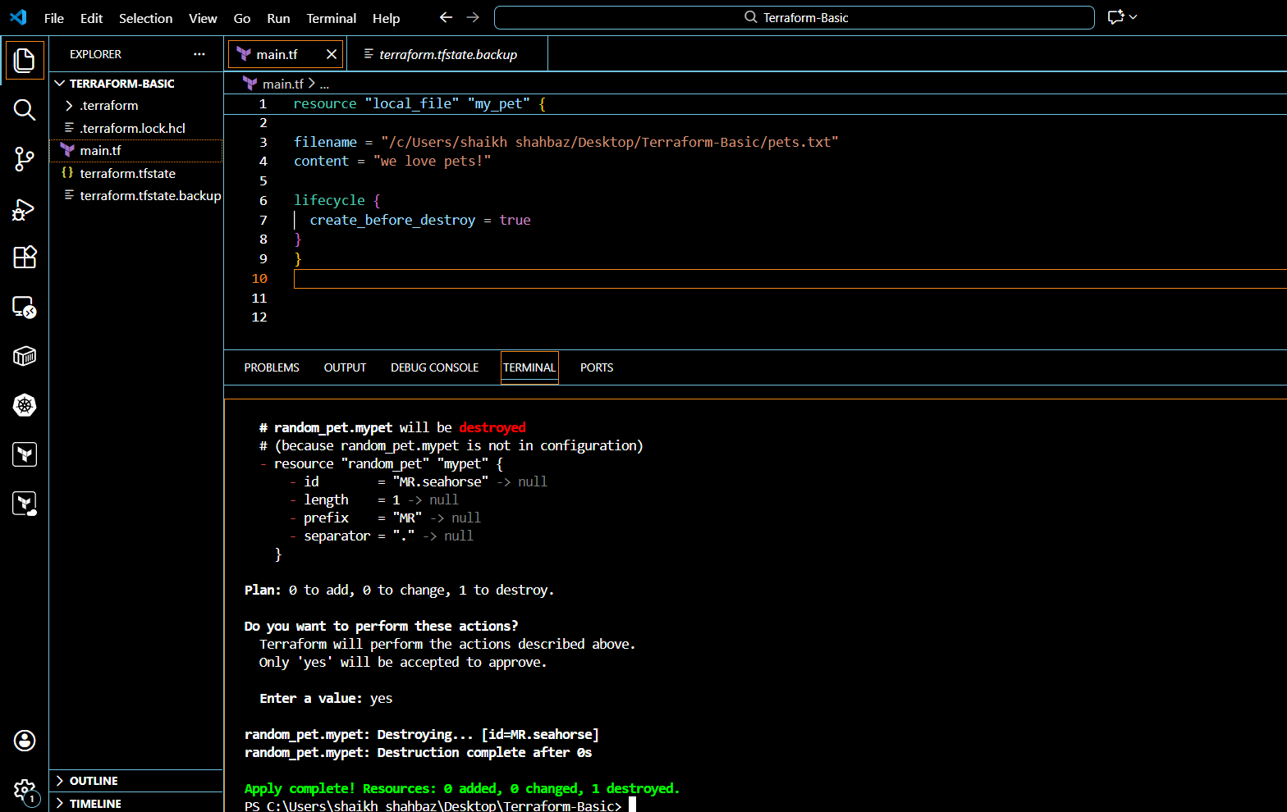
After adding then create_before_destroy inside lifecycle
save and terraform apply inside terminal

2.Prevent_destroy
Prevents accidental deletion of critical resources (e.g., DB, VPC).
Terraform will throw an error if terraform destroy tries to delete it.
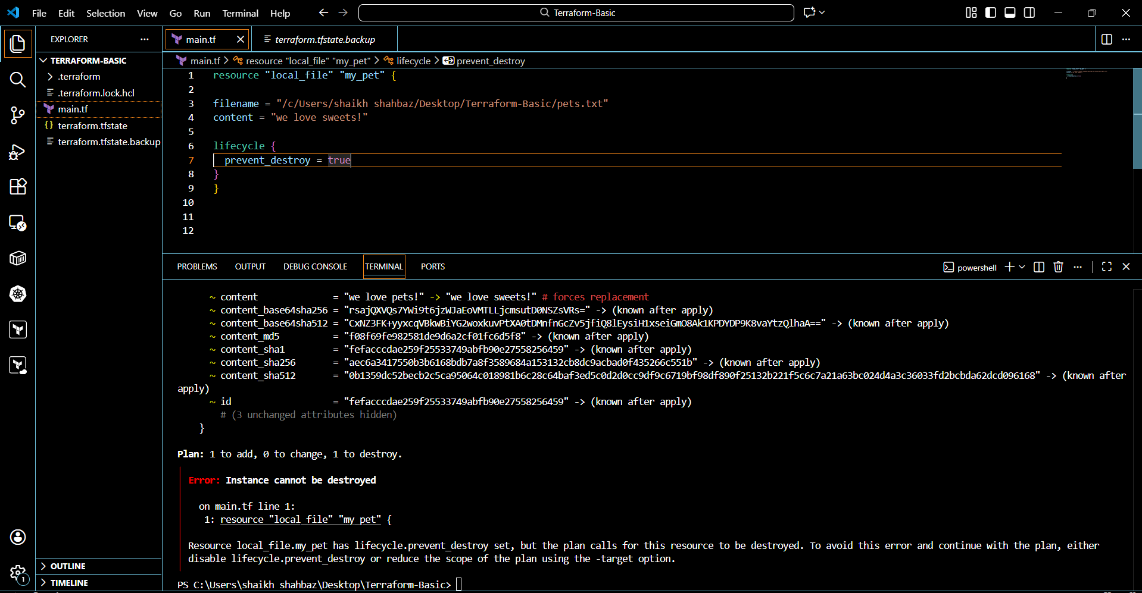
Change some content inside and add prevent_destroy inside lifecycle
Save and terraform apply

3.Ignore_changes
Ignore specific attributes from being managed by Terraform
Useful when certain values are changed outside Terraform (e.g., Tags added by another tool)
Example: Ignore tags or content.
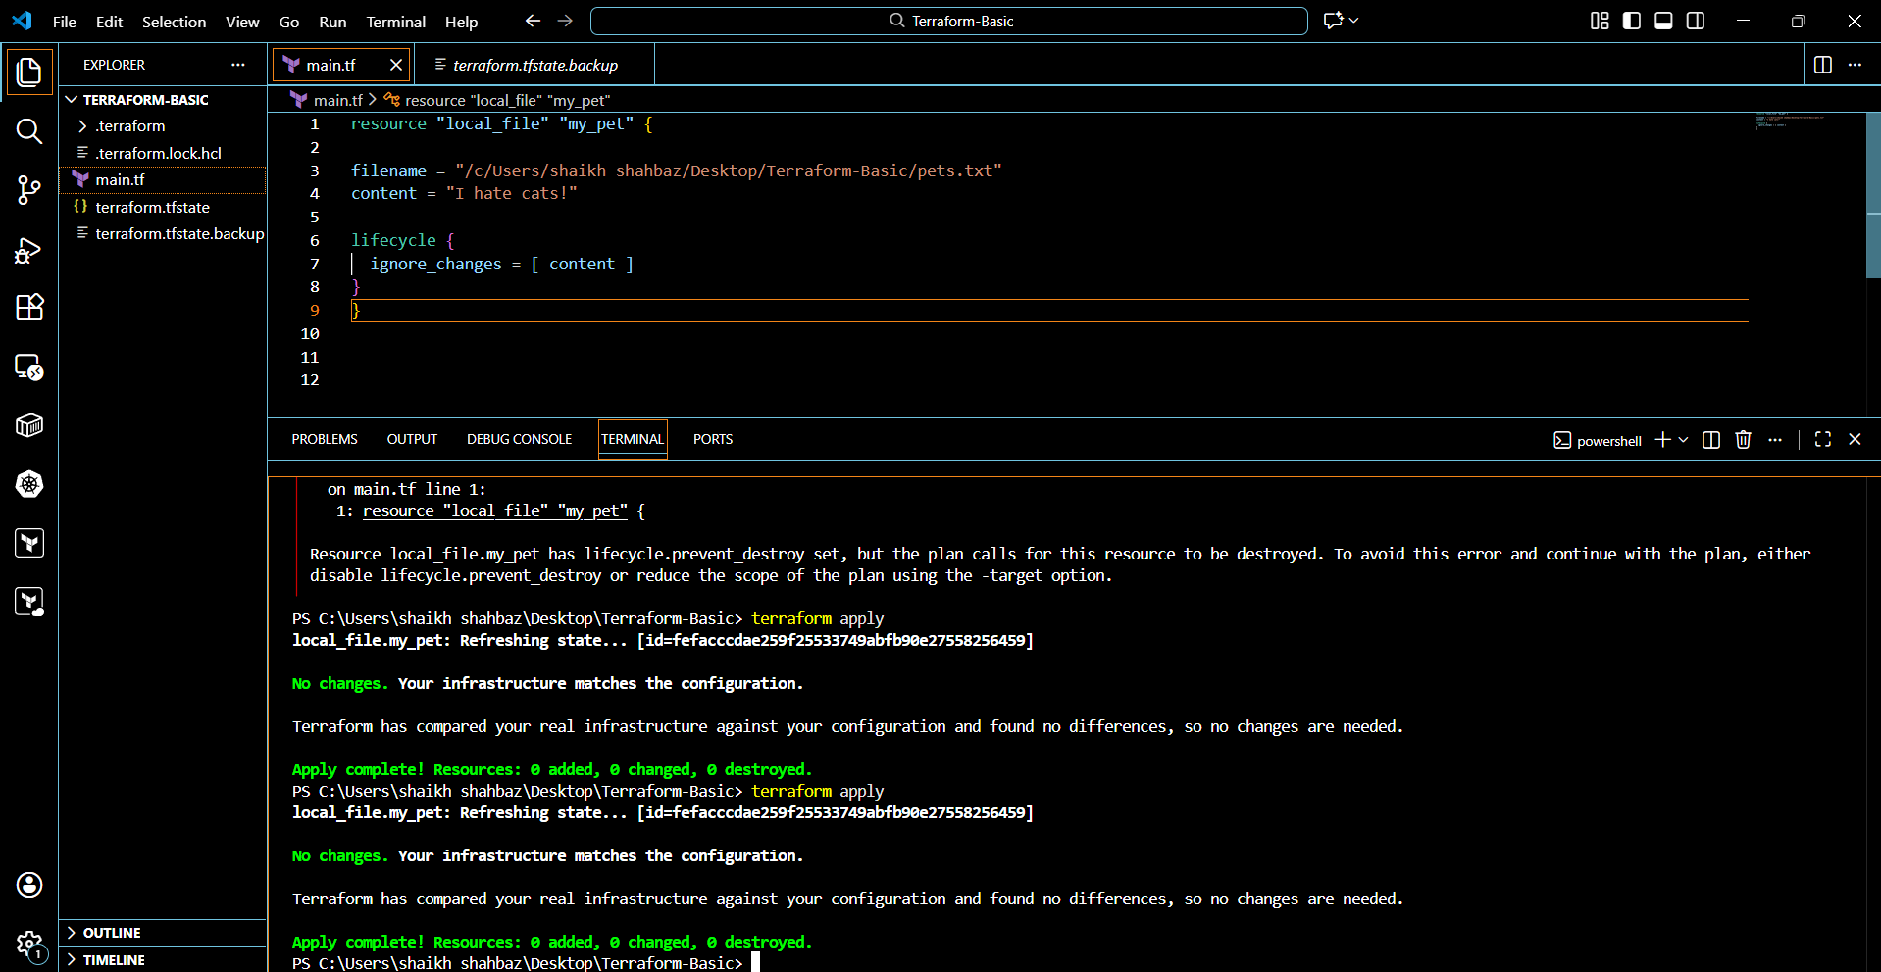

Variables in Terraform:
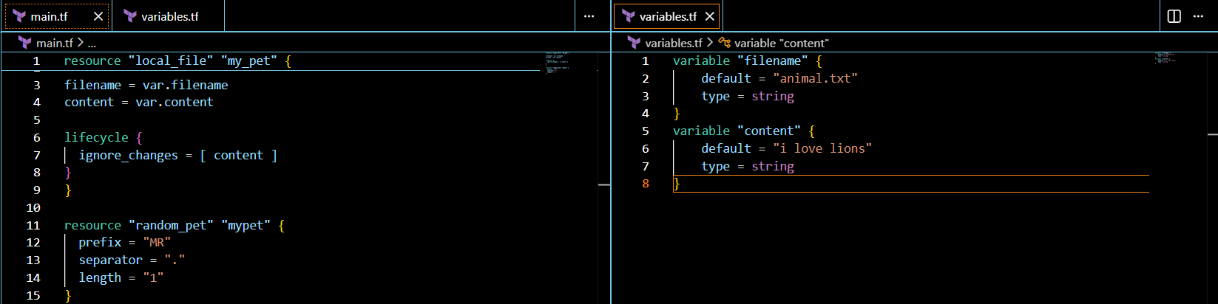
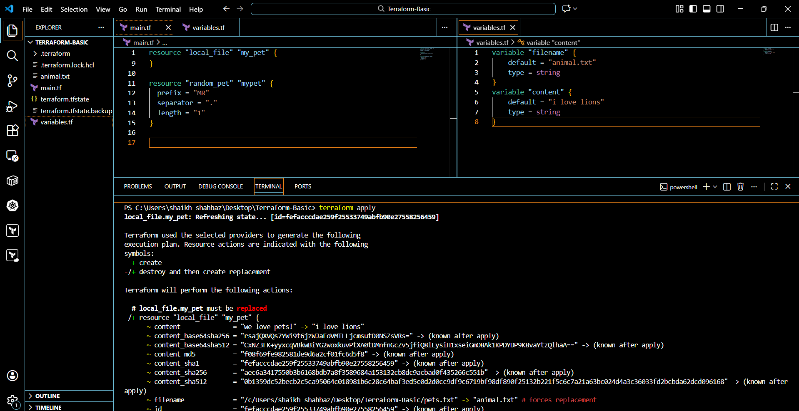
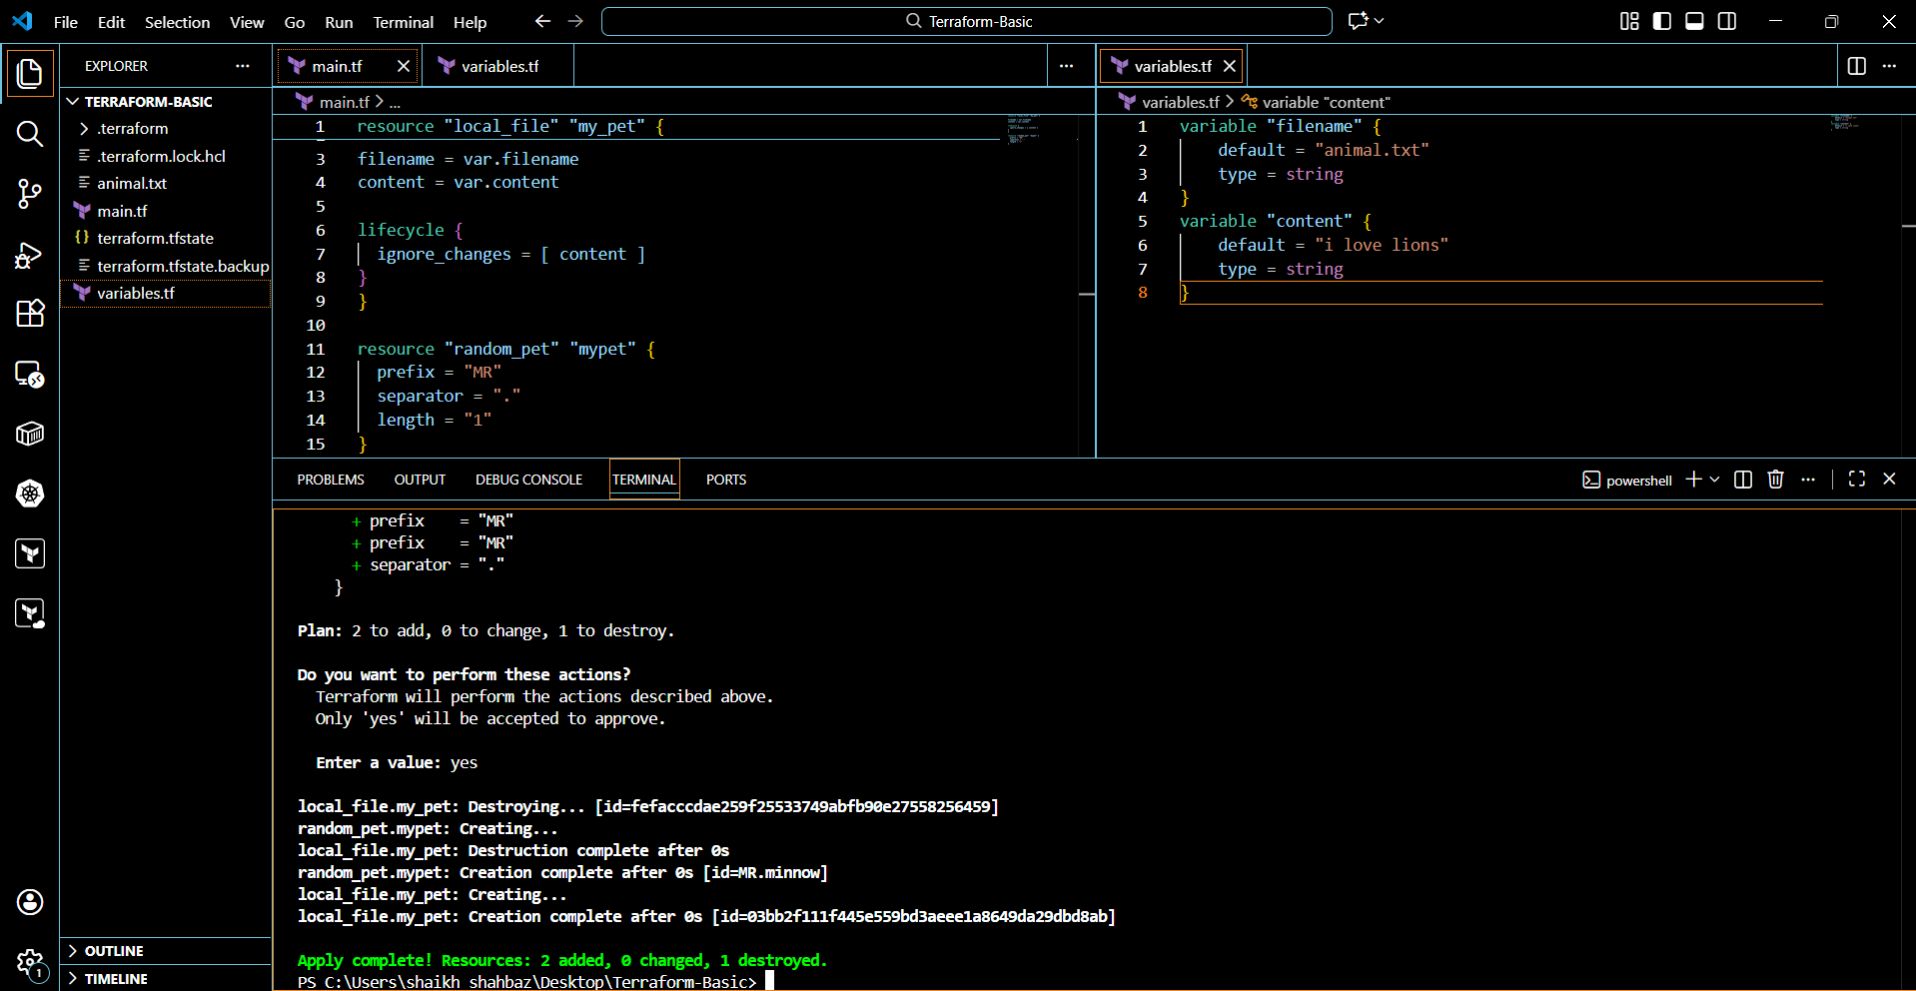

Passing values using command

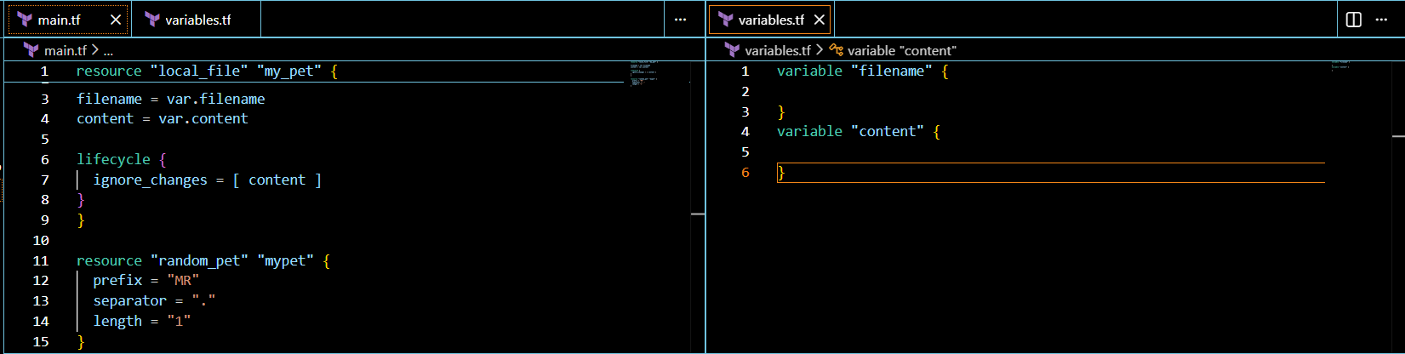

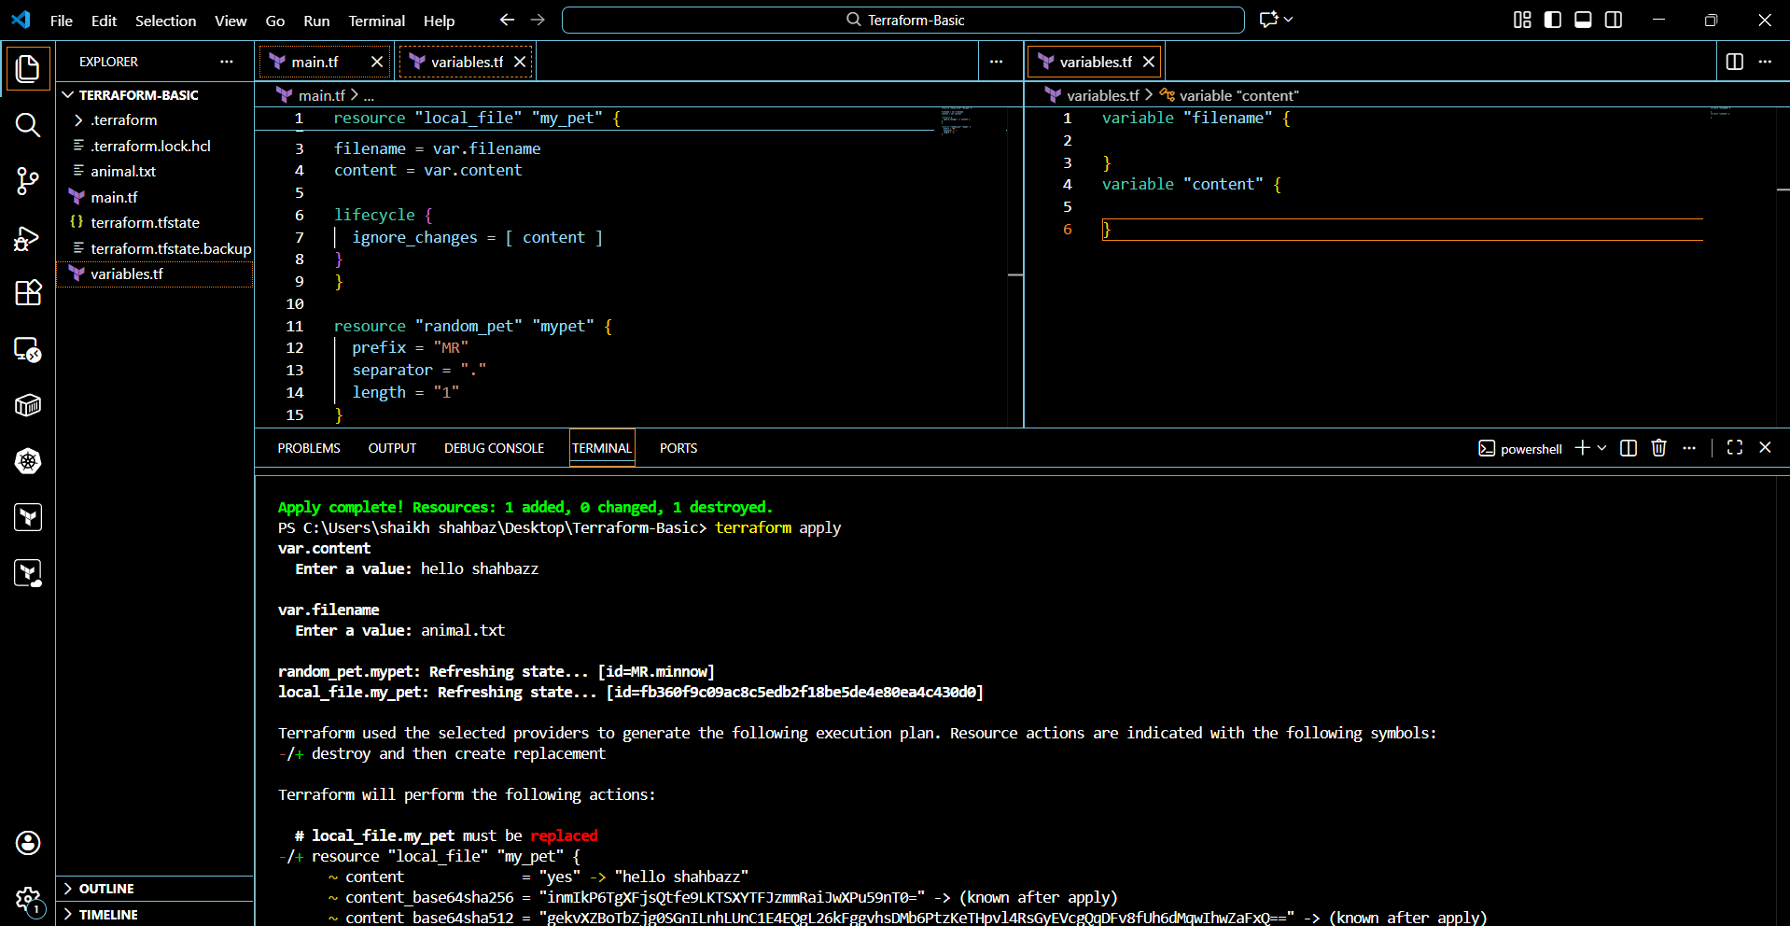
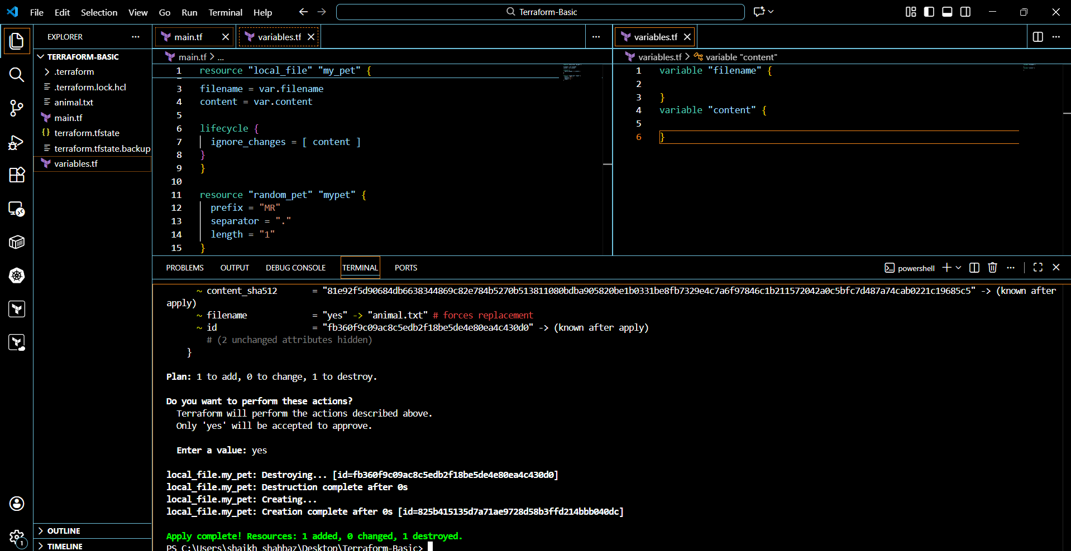
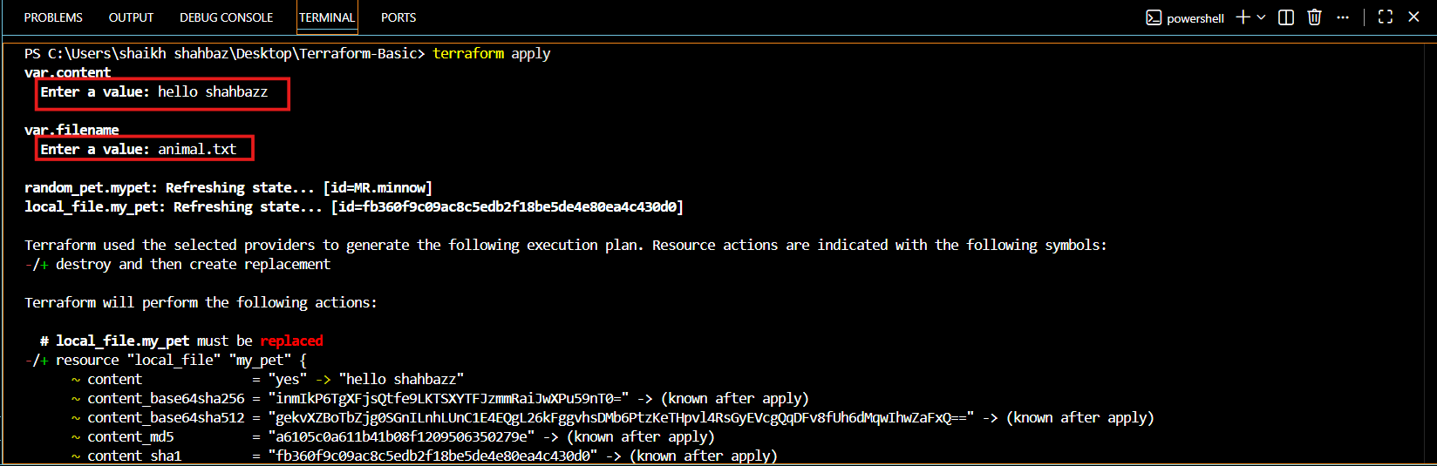
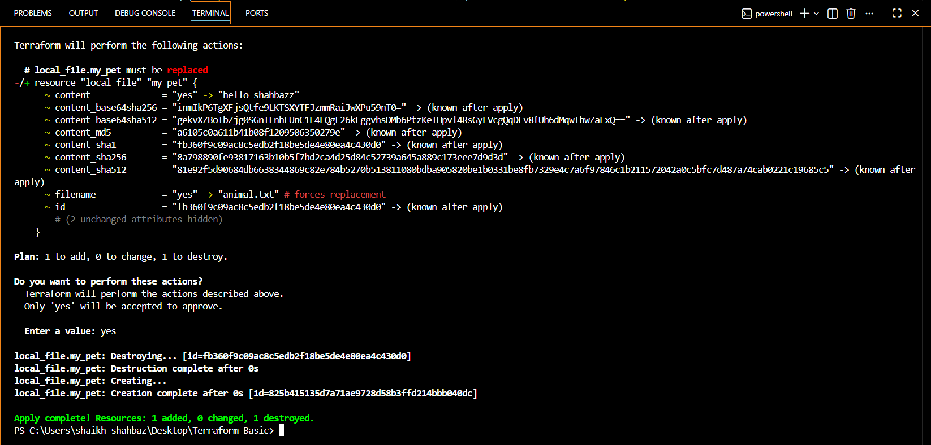

Terraform apply -var “filename=animal.txt” -var “content=hello this is shahbazz”

3.Integrate Terraform in Jenkins using the Terraform plugin.
Step 1: Install Terraform on Jenkins Server
On the Jenkins machine (EC2, VM, etc.):
# Install Terraform
sudo yum install -y wget unzip # (Amazon Linux)

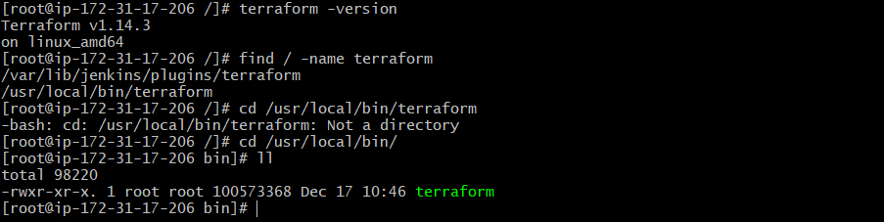

Step 2: Install Terraform Plugin in Jenkins
1. Go to Jenkins Dashboard → Manage Jenkins → Plugins → Available Plugins.

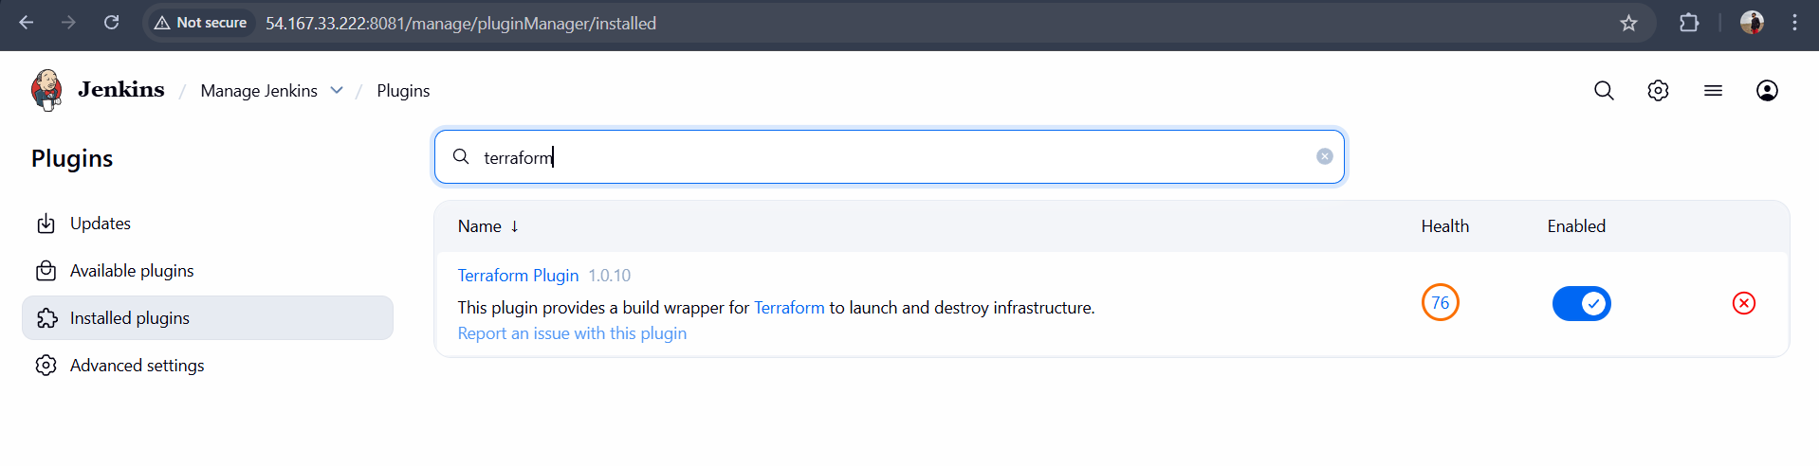

Step 3: Configure terraform in Jenkins

- Go to Manage Jenkins → Global Tool Configura?on.
- Find Terraform sec1on.
- Add a Terraform installa1on → give it a Name (example: Terraform-1.8.5) and path if manually installed.
o If plugin supports auto-install → let Jenkins download it. o If already installed → point Jenkins to /usr/local/bin/terraform. 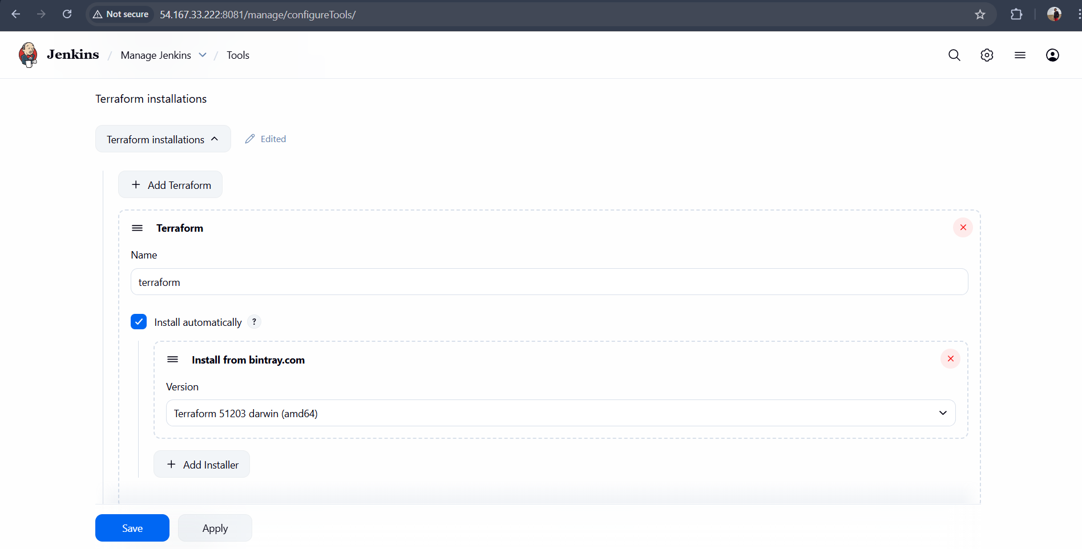
Step 4: In GitHub add these files
Main.tf and
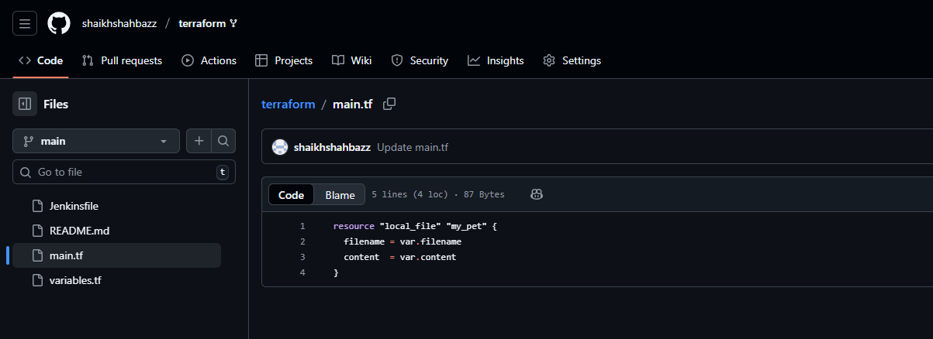
Variables.tf
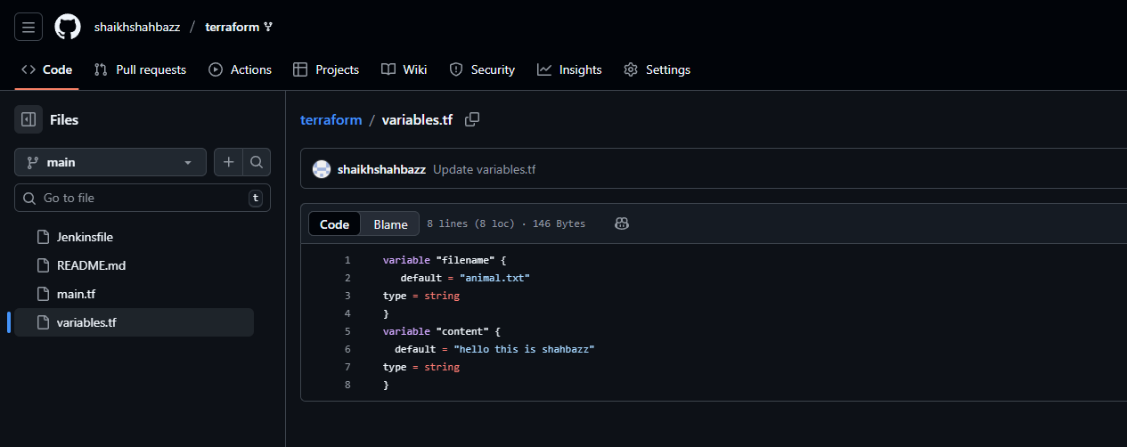
Jenkinsfile
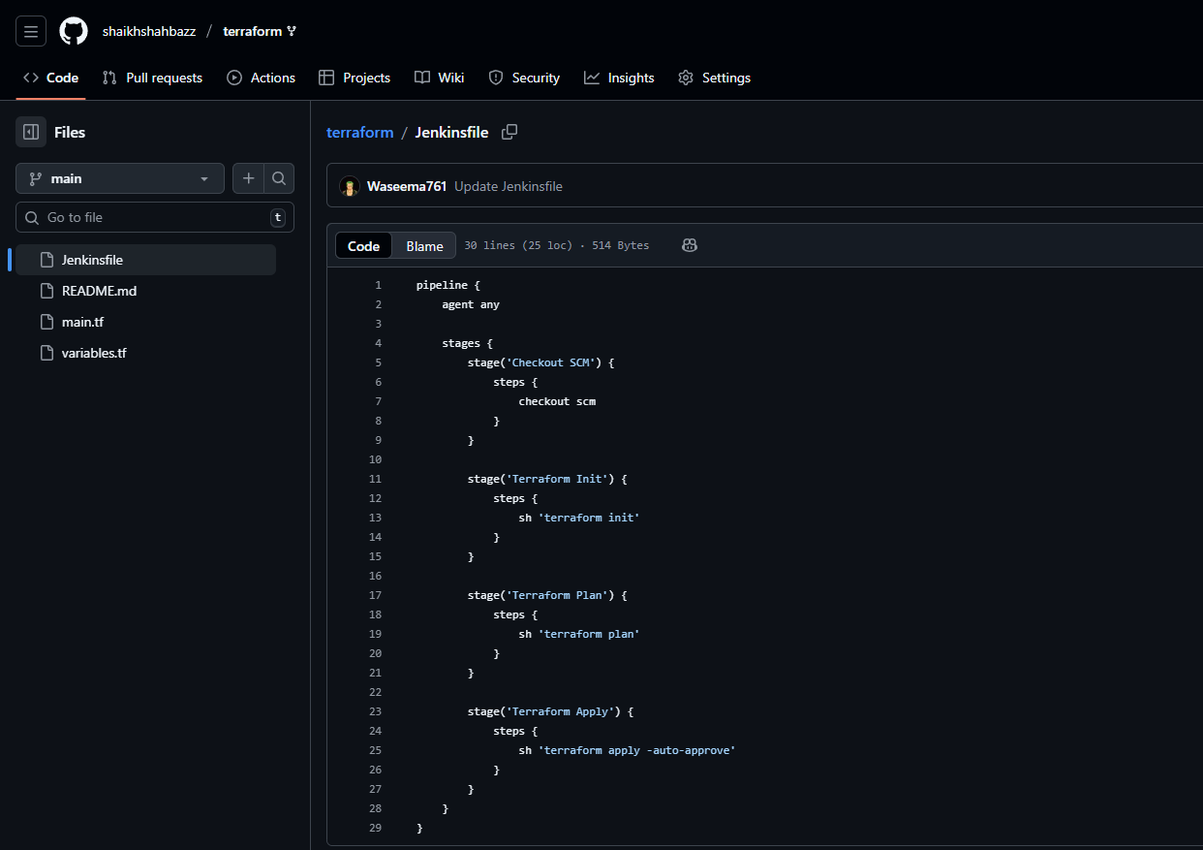
Now go to Jenkins GUI and create a job with pipeline and add the SCM.Add the GitHub repo URL and add the same branch name
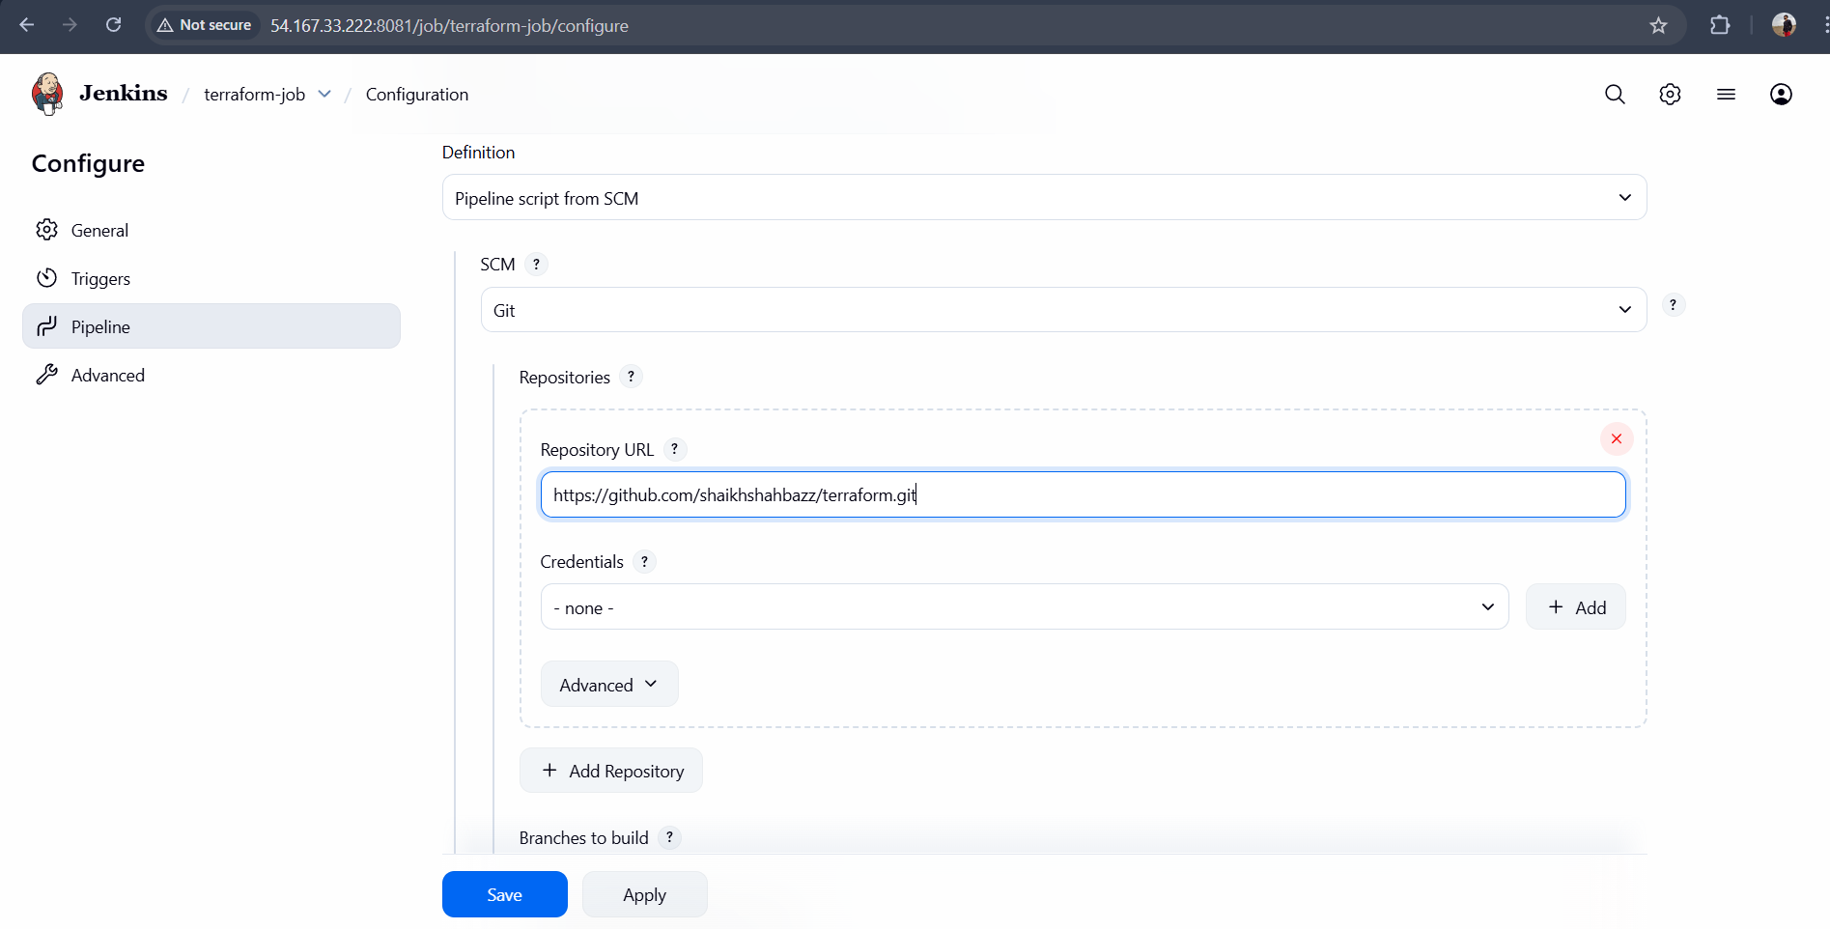
Now Click Save and Build
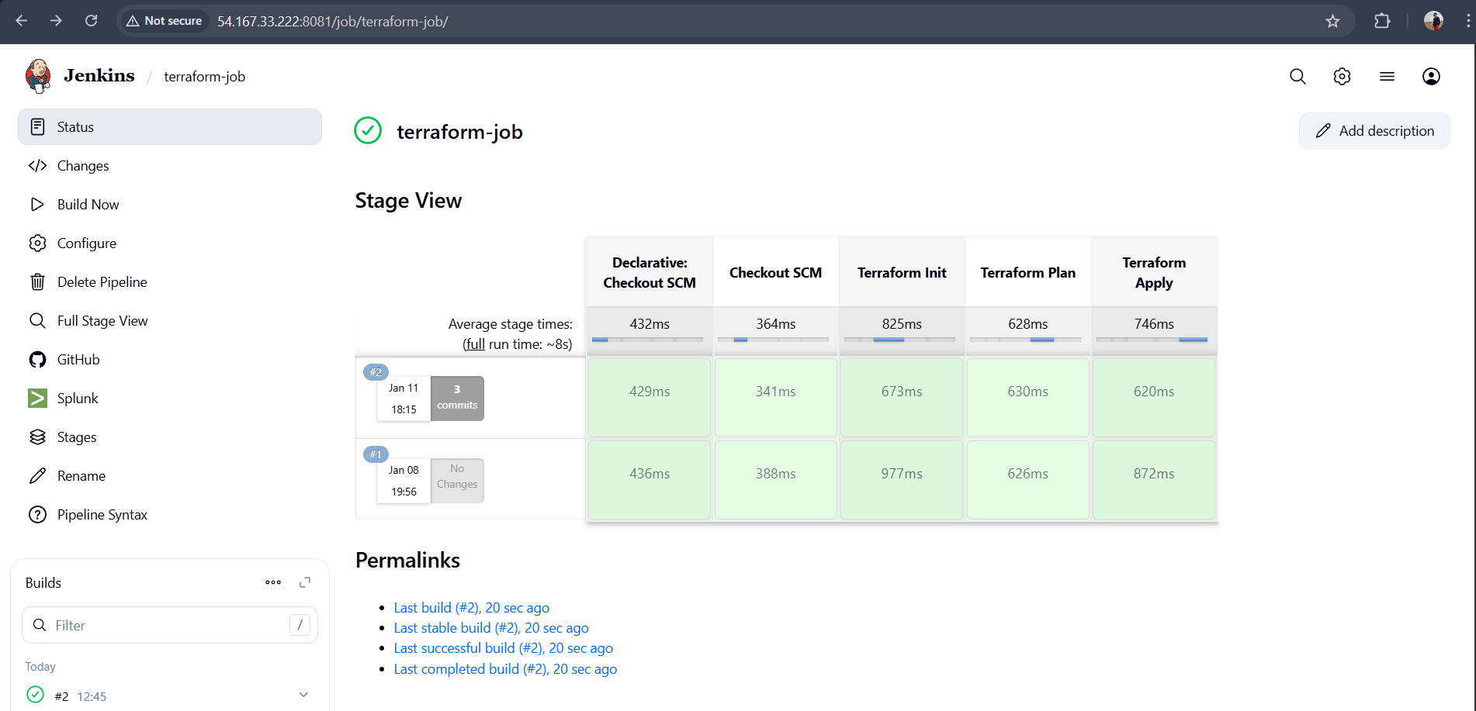
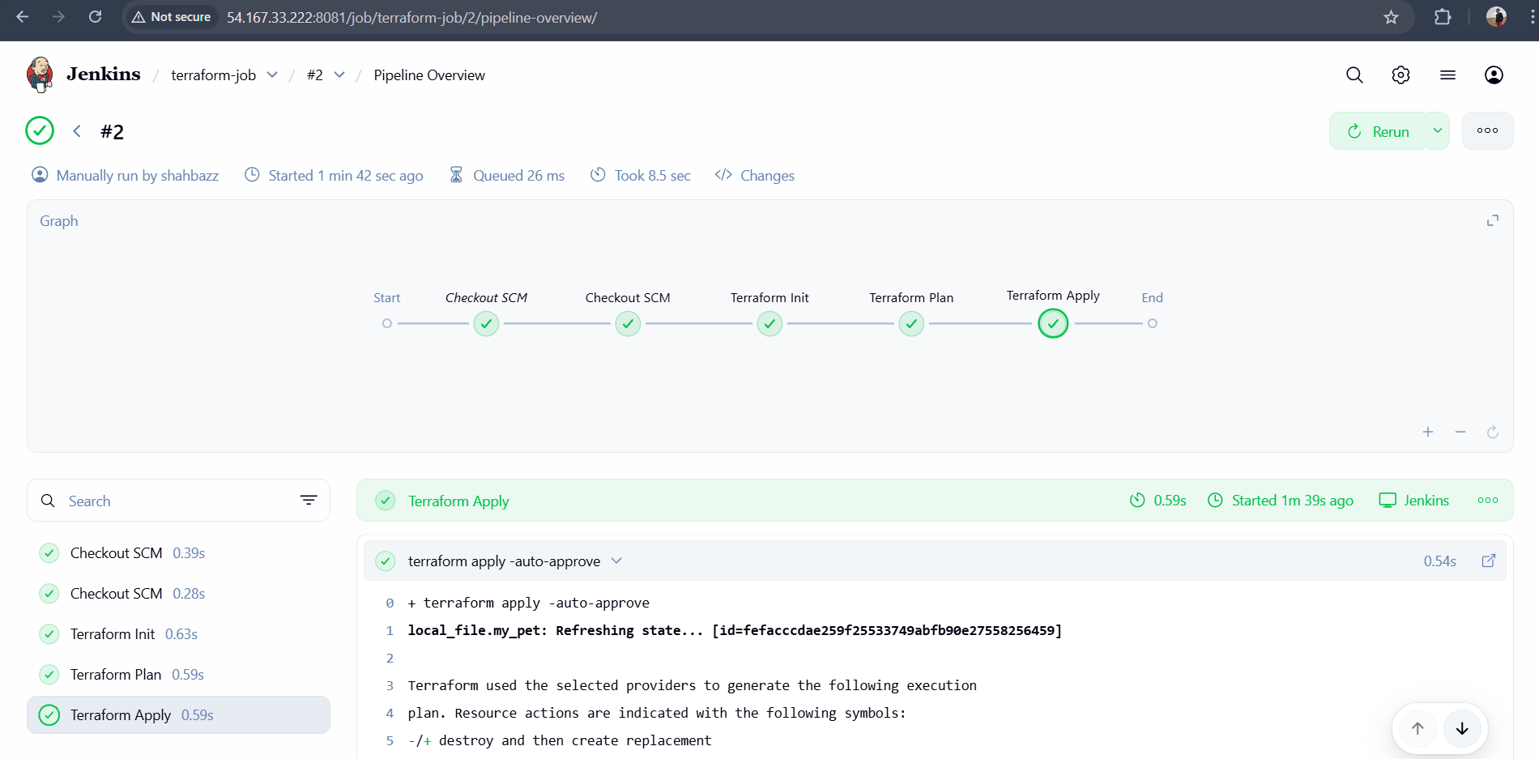
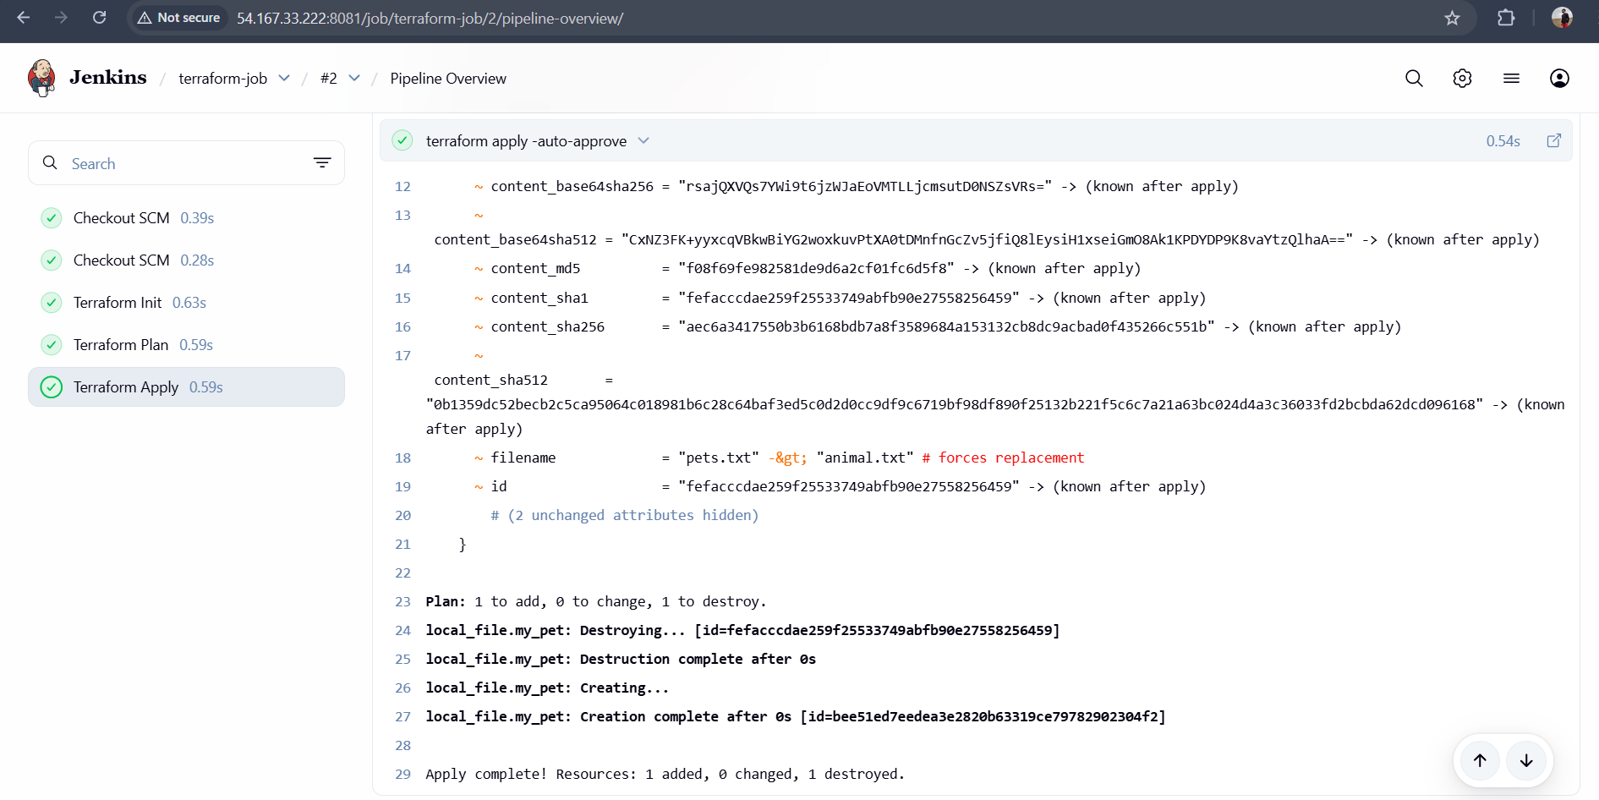
Validation:
Goto Jnekins server
cd /var/lib/Jenkins/workspace
cd terraform <jon-name>
